**IEEE**

***Institute of Electrical and Electronic Engineers***

**Thursday, September 17, 2015**



8054 Frank Ave., North Canton

(Just South of Shuffle on Frank Ave.)

**System Integration/Automation Training Facility Tour**

**Robert Thoma**

Owner/CEO, Thoma Technologies, Inc.

6:00 pm – Meet at Thoma Technologies, Inc.

6:15 pm – Automation Demonstration and discussions

6:40 pm – Leave Thoma Technologies and head to **Technical Training Institute** at 5377 Lauby Rd., North Canton

6:45 pm – Commence presentations on computer lab stations displaying promotional video, a Power Point Presentation, and our new website.

7:30 pm – Samantha’s Restaurant for Dinner (**Order from the Menu**)

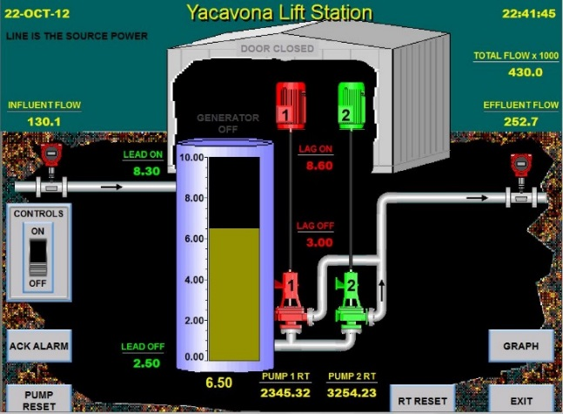Please contact Rick Buchanan at (330) 497-8250 or [R.Buchanan@ieee.org](mailto:R.Buchanan@ieee.org) for reservations **no later than Tuesday, September 15.**